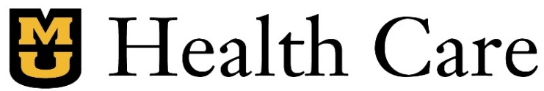
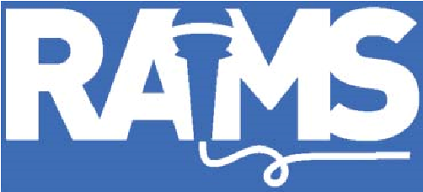

1st Annual RAMS Golf Tournament
Sunday, September 8th, 2019
Lake of the Woods Golf Course, Columbia, MO

Sponsorship Levels

The success of this event requires support from the community. We are asking if you would join us for a great day of golf while changing the lives of families living with Multiple Sclerosis.
Platinum - $5000 (one spot available)
Includes:
- (2) 4-person teams in the tournament
- Signage recognition at the clubhouse on the day of the event
- Recognition of sponsorship level on RAMS social media (e.g., website, Facebook, Twitter, etc.)
- Verbal recognition during the awards presentation and pre-round announcements
- Dedicated space next to the clubhouse for company promotion (i.e., booth)
- Recognition in event program
- Recognition at other RAMS events throughout the Mizzou school year (5k, Rock-It, Speaker night, Comedy night, Trivia night, etc.)
- Logo on RAMS general merchandise throughout the academic year as well as 5k shirt (over 4000 shirts distributed!)

Front 9/Back 9 - $1000 (two spots available)
Includes:
- (1) 4-person team in the tournament
- Signage recognition at tees and at the clubhouse on the day of the event
- Recognition of sponsorship level on RAMS social media (e.g., website, Facebook, Twitter, etc.)
- Verbal recognition during the awards presentation and pre-round announcements
- Dedicated space next to the clubhouse for company promotion (i.e., booth)
- Recognition in event program

Lunch - $875 or provide lunch for 120 golfers
Includes:
- Dedicated space next to the clubhouse for company promotion (i.e., booth)
- Signage recognition at the clubhouse & in the lunch pavilion on the day of the event
- Recognition of sponsorship level on RAMS social media (e.g., website, Facebook, Twitter, etc.)
- Verbal recognition during the awards presentation and pre-round announcements
- Recognition in event program
Breakfast - $500 or provide breakfast for 120 golfers
Includes:
- Signage recognition at the clubhouse in the breakfast nook on the day of the event
- Recognition of sponsorship level on RAMS social media (e.g., website, Facebook, Twitter, etc.)
- Verbal recognition during the awards presentation and pre-round announcements
- Recognition in event program

Beverage - $500
Includes:
- Signage recognition on the beverage cart that will circulate throughout the course all day
- Recognition of sponsorship level on RAMS social media (e.g., website, Facebook, Twitter, etc.)
- Verbal recognition during the awards presentation and pre-round announcements
- Recognition in event program

Driving Range - $400 (driving range availability dependent on sponsorship securement)
Includes:
- Dedicated space next to the driving range or clubhouse for company promotion (i.e., booth)
- Signage recognition on the driving range
- Recognition of sponsorship level on RAMS social media (e.g., website, Facebook, Twitter, etc.)
- Verbal recognition during the pre-round announcements
- Recognition in event program

Longest Drive - $200
Includes:
- Signage recognition at The Longest Drive Hole
- Recognition of sponsorship level on RAMS social media (e.g., website, Facebook, Twitter, etc.)
- Verbal recognition during the awards presentation and pre-round announcements
- Recognition in event program

Longest Putt - $200
Includes:
- Signage recognition at The Longest Putt Hole
- Recognition of sponsorship level on RAMS social media (e.g., website, Facebook, Twitter, etc.)
- Verbal recognition during the awards presentation and pre-round announcements
- Recognition in event program

Hole in One - $200
Includes:
- Signage recognition at The Hole in One Sponsor
- Recognition of sponsorship level on RAMS social media (e.g., website, Facebook, Twitter, etc.)
- Verbal recognition during the awards presentation and pre-round announcements
- Recognition in event program

Individual Hole* - $200/$100, if you have a team already!
Includes:
- Signage recognition at your tee
- Recognition of sponsorship level on RAMS social media (e.g., website, Facebook, Twitter, etc.)
- Recognition in event program

*(Hole numbers are available on a first come, first served basis)

Prize Sponsor

Includes:
- Recognition of sponsorship level on RAMS social media (e.g., website, Facebook, Twitter, etc.)
- Verbal recognition during the awards presentation and pre-round announcements
- Recognition in event program

Seeking cash, gift cards, experiences, or items of $20+ value that can be used to group together prize packs

Please contact us if you are interested in a team and/or sponsoring!
Jamie McDonald
Coordinator of MS Institute
573-882-6767
mcdonaldja@health.missouri.edu

Parker Swanson
RAMS Director/Tournament Captain
913-982-6353
rockinagainstMS@gmail.com

